  Lab 0  BREADBOARD IMPLEMENTATION  Group：01357101 01357142 (Fill in all group members' student IDs this week)  Name：黃翊宏 Student ID：01357101 |  | Notice  - All files must be converted to PDF format before submission.  Submission deadline: Next Tuesday at 1:00 PM.  - When taking photos of the beadboard, ensure the serial number is visible.  File names should follow the format:  LabX_StudentID,  e.g., Lab1_00857001.
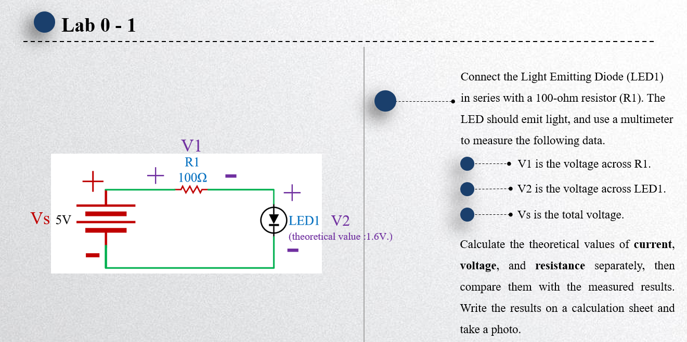
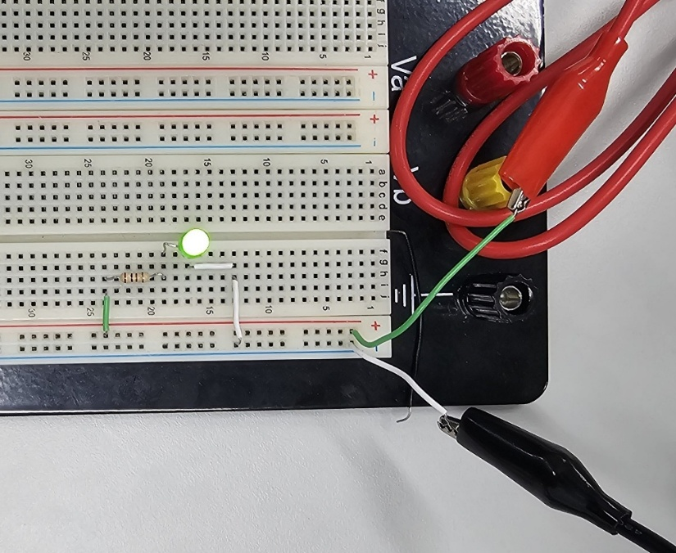
- Breadboard Implementation Circuit Diagram (Make sure the circuit is fully connected and the LED is illuminated.)

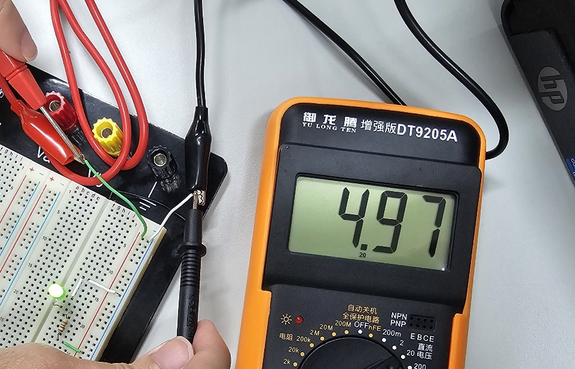
- Vs Voltage Measurement Result (Take a photo of the multimeter display)
Answer: 4.97 V
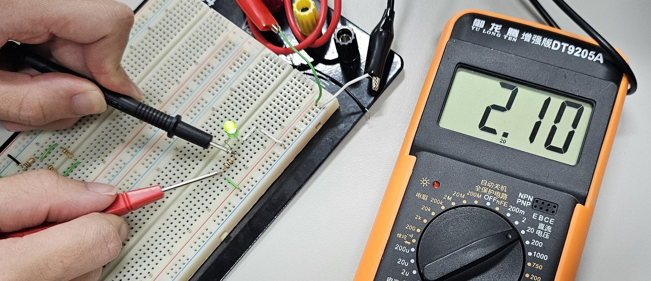
- V1 Voltage Measurement Result (Take a photo of the multimeter display)
Answer: 2.10 V

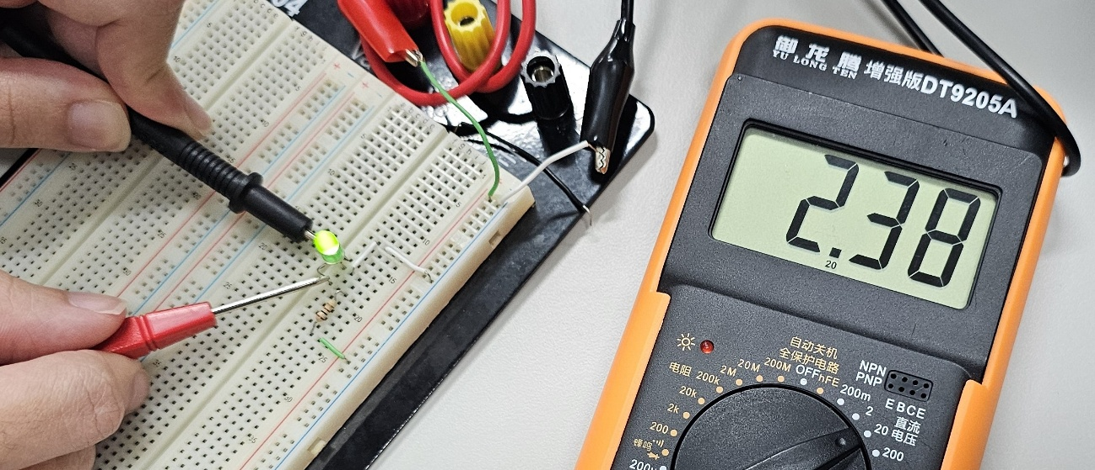
- V2 Voltage Measurement Result (Take a photo of the multimeter display)
Answer: 2.38 V

- Theoretical Values of Voltage, Resistance, and Current vs. Measured Values (Numerical Data)

$V_{s}$ 處資料：
 | Voltage ( $Volt$ ) | Resistance ( $Ohm$ ) | Current ( $Ampere$ )
Theoretical Values | 5.00 | 147.06 | 0.034
Measured Values | 4.97 | 26.43 | 0.188

$V_{1}$ 處資料：
 | Voltage ( $Volt$ ) | Resistance ( $Ohm$ ) | Current ( $Ampere$ )
Theoretical Values | 3.4 | 100 | 0.034
Measured Values | 2.10 | 95.1 | 0.188

$V_{2}$ 處資料：
 | Voltage ( $Volt$ ) | Resistance ( $Ohm$ ) | Current ( $Ampere$ )
Theoretical Values | 1.60 | 47.06 | 0.034
Measured Values | 2.38 | 261 | 0.188

- Theoretical Calculation Process
$$I_{s}= \frac{V_{s}-V_{2}}{R_{1}}= \frac{5-1.6}{100}=0.034 R_{s}=\frac{V_{s}}{I_{s}}= \frac{5}{0.034}≈147.06$$
$$V_{1}= I_{1}×R_{1}=0.034 ×100=3.4$$
$$R_{2}= \frac{V_{2}}{I_{2}}=\frac{1.60}{0.034}≈47.06$$

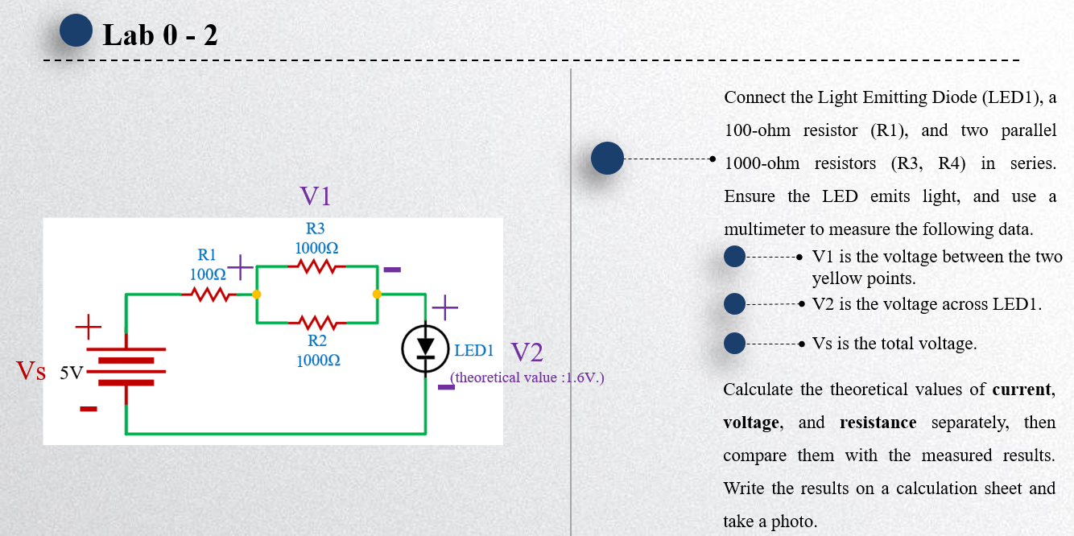
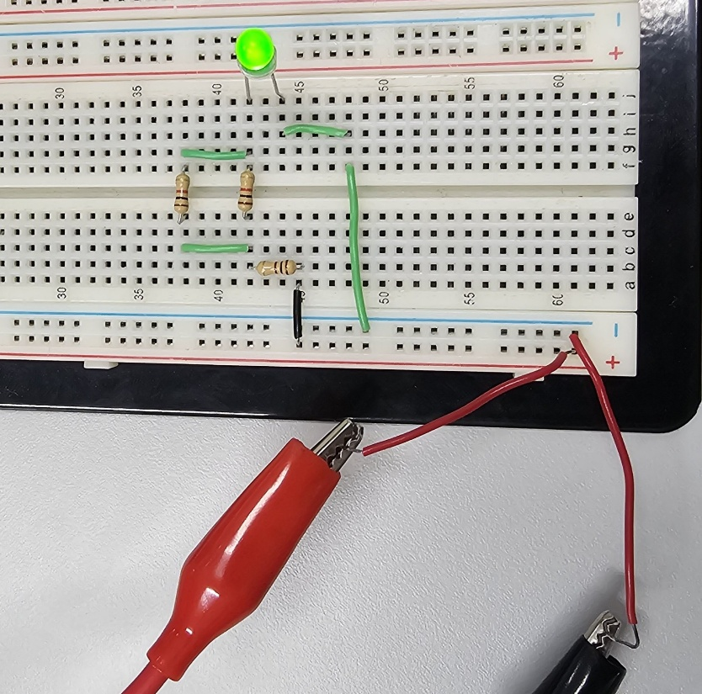
- Breadboard Implementation Circuit Diagram (Make sure the circuit is fully connected and the LED is illuminated.)

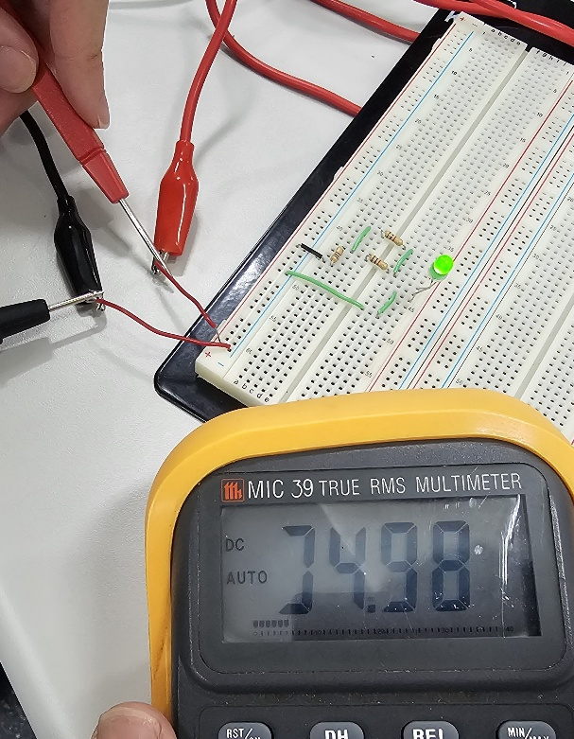
- Vs Voltage Measurement Result (Take a photo of the multimeter display)
Answer: 4.98 V
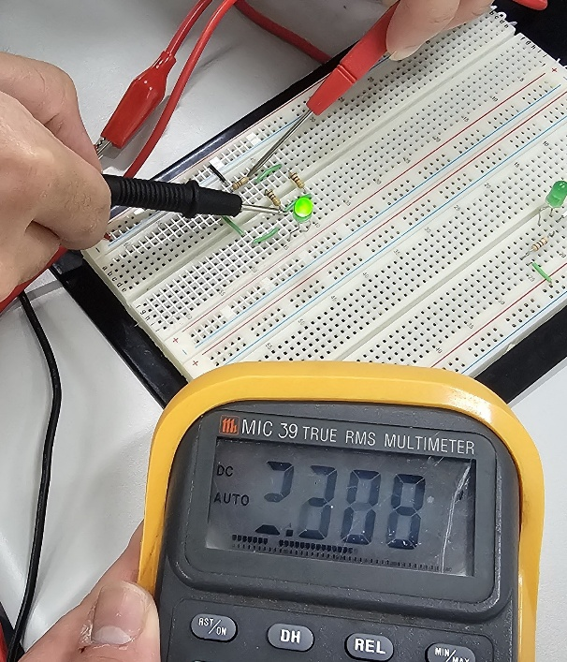
- V1 Voltage Measurement Result (Take a photo of the multimeter display)
Answer: 2.309 V
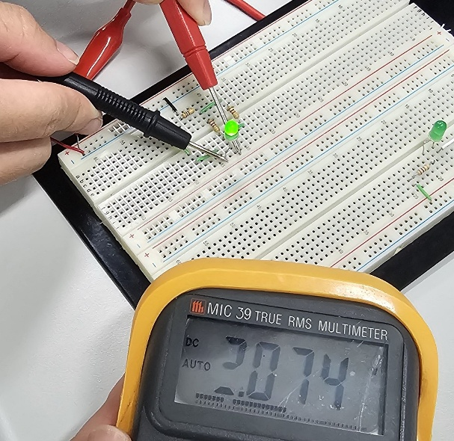
- V2 Voltage Measurement Result (Take a photo of the multimeter display)
Answer: 2.074 V

- Theoretical Values of Voltage, Resistance, and Current vs. Measured Values (Numerical Data)

$V_{s}$ 處資料：
 | Voltage ( $Volt$ ) | Resistance ( $Ohm$ ) | Current ( $Ampere$ )
Theoretical Values | 5.00 | 877.19 | 0.0057
Measured Values | 4.98 | 61 | 0.081

$V_{1}$ 處資料：
 | Voltage ( $Volt$ ) | Resistance ( $Ohm$ ) | Current ( $Ampere$ )
Theoretical Values | 5.7 | 1000 | 0.0057
Measured Values | 2.309 | 989 | 0.081

$V_{2}$ 處資料：
 | Voltage ( $Volt$ ) | Resistance ( $Ohm$ ) | Current ( $Ampere$ )
Theoretical Values | 1.60 | 280.70 | 0.0057
Measured Values | 2.074 | 261 | 0.081

- Theoretical Calculation Process
$$\frac{1}{R_{p}}= \frac{1}{R2}+\frac{1}{R3}= \frac{1}{1000}+\frac{1}{1000}=\frac{1}{500} R_{T}=R_{p}+R1= 500+100=600$$
$$I_{s}= \frac{V_{s}-V_{2}}{R_{T}}= \frac{5-1.6}{600}≈0.0057 R_{s}=\frac{V_{s}}{I_{s}}= \frac{5}{0.0057}≈877.19$$
$$V_{1}= I_{1}×R_{1}=0.0057×1000=5.7$$
$$R_{2}= \frac{V_{2}}{I_{2}}= \frac{1.6}{0.0057}≈280.70$$

- Lab Summary and Reflection：

Lab Summary:
In today’s Lab experiment, the objective was to implement and analyze a digital logic circuit using a breadboard. The experiment involved constructing a circuit that incorporated resistors, an LED, and measurement instruments to observe the behavior of series-parallel networks in a practical setting. Two distinct trial setups were conducted. In the first trial, voltage readings were recorded as 4.97 V, 2.10 V, and 2.38 V, while the corresponding theoretical values were calculated as 5.00 V, 3.40 V, and 1.60 V. In the second trial, the measured voltages were approximately 4.98 V, 2.309 V, and 2.074 V, with theoretical predictions provided for each circuit segment as well. Additionally, comparisons of measured versus theoretical resistance and current values were made, highlighting noticeable discrepancies likely due to component tolerances, connection losses, and inherent measurement uncertainties.

Reflection:
This laboratory exercise has been instrumental in bridging theoretical concepts with practical implementation. The process of assembling the breadboard circuit and taking precise measurements underscored the challenges of real-world circuit behavior—particularly the deviations from ideal calculations. The observed differences between the theoretical and measured values not only illustrate the impact of resistor tolerances and contact resistance but also emphasize the importance of using calibrated instruments for accuracy. Overall, the lab has deepened my understanding of fundamental electrical principles, such as Ohm’s Law and Kirchhoff’s Voltage Law, and reinforced the necessity of meticulous experimental procedures. Moving forward, I intend to improve circuit assembly techniques and measurement protocols to minimize discrepancies and achieve closer alignment with theoretical predictions.

